IoT-Based Health Monitoring System

Embedded systems

Submitted in partial fulfillment for the award of the course

Of

BACHELOR OF ENGINEERING

In

COMPUTER SYSTEMS ENGINEERING

BY: AYESHA ANSARI (133-22-0005) & HABEEBAN MEMON (133-22-0033)

INSTRUCTOR: SIR JUNAID AHMED AND SIR ASIF ALI

Abstract:
In this project, a Health Monitoring System is designed to measure and monitor critical health parameters, namely heart rate (BPM) and room temperature. Using a PulseSensor for heart rate detection, an LM35 temperature sensor for room temperature measurement, and an ESP32 microcontroller for data processing, the system provides real-time feedback on these parameters. The data is displayed on a 16x2 LCD, and if any abnormalities are detected in the heart rate, an email alert is sent to the doctor. The system is further integrated with the Blynk IoT app, allowing remote monitoring of the health parameters. The project aims to provide a low-cost, real-time health monitoring solution, improving early detection of health issues and facilitating timely intervention by healthcare providers.

Introduction:
In recent years, healthcare technologies have seen substantial advancements, particularly with the development of IoT-based health monitoring systems. These systems enable continuous tracking of various health parameters, offering early detection of health issues, which can be critical in preventing severe medical conditions. This project focuses on developing a real-time health monitoring system that can measure and monitor two important health parameters: heart rate and room temperature.
Traditionally, heart rate and temperature monitoring systems were complex and costly, primarily used in hospitals or healthcare facilities. However, with the rise of microcontrollers such as the ESP32 and easily accessible sensors, it is now possible to build affordable and effective systems for personal health monitoring at home. The PulseSensor provides an accurate and reliable heart rate measurement, while the LM35 sensor tracks room temperature in real-time. The use of the Blynk app allows users and healthcare providers to remotely monitor the data, while an email alert system ensures that medical professionals are notified in case of emergencies.
This health monitoring system is designed to address the increasing need for continuous and remote health monitoring, especially for individuals with chronic health conditions, the elderly, or those recovering from medical procedures. This report discusses the various components, the methodology used in the development of the system, the results, and the conclusion drawn from the project.

Project Objective:
The primary objective of this project is to develop a system that allows continuous monitoring of vital health signs such as heart rate and room temperature, providing real-time feedback to the user and healthcare providers. The system aims to:
- Measure and display the heart rate in real-time.
- Monitor room temperature and display it on a local LCD screen.
- Alert the user and doctor via email if the heart rate is dangerously high or low.
- Allow remote monitoring of the data via the Blynk IoT app.
- Ensure a user-friendly interface with both local (LCD) and remote (Blynk) monitoring features.
This system can serve as an early warning mechanism, ensuring that users receive timely alerts when their health metrics fall outside the normal range.
---------------------------------------------------------------------------------------------------------------------

Methodology:
- Hardware Components:
  - ESP32 Microcontroller: This serves as the central processing unit for the entire system. It is responsible for data collection, processing, and communication with the Blynk app via Wi-Fi.
  - PulseSensor: This optical sensor detects the user’s heart rate by measuring the variations in blood flow. The sensor sends analog signals to the ESP32, which is processed to calculate the Beats Per Minute (BPM).
  - LM35 Temperature Sensor: The LM35 is a temperature sensor that outputs an analog voltage proportional to the temperature. The ESP32 reads the sensor's output and converts it into Celsius.
  - 16x2 LCD: The LCD displays the heart rate and temperature data in real time, providing a local visual representation of the health parameters.
  - Buzzer: The buzzer is used to alert the user when the heart rate goes beyond the normal range.
  - Wi-Fi Connection: The ESP32 connects to the Wi-Fi network to enable communication with the Blynk app and send email alerts using the SMTP protocol.
- Software Components:
  - Blynk App: The Blynk app is used to remotely monitor the heart rate and temperature. The data is transmitted in real-time, allowing healthcare providers or caregivers to access it from anywhere.
  - ESP_Mail_Client Library: This library is used to send email alerts to the doctor when the heart rate exceeds or falls below the defined thresholds.
  - PulseSensorPlayground Library: This library helps in interfacing the PulseSensor with the ESP32, allowing easy measurement of the heart rate.
  - LiquidCrystal Library: The LiquidCrystal library is used to control the 16x2 LCD for displaying the data.
- System Workflow:
  - The system continuously monitors the heart rate using the PulseSensor. If a heartbeat is detected, the BPM is calculated and displayed on the LCD.
  - Simultaneously, the LM35 sensor reads the room temperature and displays it on the second line of the LCD.
  - If the heart rate falls outside the normal range (defined as 60-100 BPM), the system triggers an alert by displaying “High HR Alert” or “Low HR Alert” on the LCD, sounding the buzzer, and sending an email alert to the doctor.
  - All the health data is sent to the Blynk app for remote monitoring, and the system ensures that a new email is not sent until at least 15 seconds have passed since the last alert.

----------------------------------------------------------------------------------------------------

System Design and Workflow:
The system is designed to continuously monitor the user’s heart rate and room temperature, providing real-time data on a local LCD and through the Blynk app. It also incorporates safety features by notifying a doctor via email when the heart rate deviates from normal ranges.

Key Functions:
- Heart Rate Monitoring:
  - The PulseSensor is connected to an analog pin on the ESP32 and continuously reads the user’s heart rate.
  - The PulseSensorPlayground library is used to interface with the sensor, which is capable of detecting pulse beats and calculating the Beats Per Minute (BPM).
  - The heart rate is checked against predefined normal heart rate ranges (60 to 100 BPM). If the heart rate falls outside this range, an alert is triggered on the LCD, and the system sends an email notification to the doctor.
- Temperature Monitoring:
  - The LM35 temperature sensor is connected to the ESP32, and its readings are converted from analog to digital format using the analogRead() function.
  - The temperature is then converted into Celsius and displayed on the LCD.
- Blynk Integration:
  - The Blynk app is used to remotely monitor the health parameters. The Blynk library for ESP32 allows sending the heart rate (V3) and room temperature (V4) data to the app in real-time.
- Email Alerts:
  - The ESP_Mail_Client library is used to send email alerts to the doctor in case the heart rate goes outside the acceptable range.
  - The SMTP server (configured with Gmail) is used to send the email. The ESP32 connects to the internet via Wi-Fi to facilitate this process.
  - The email is sent with a subject and message body containing the details of the abnormal heart rate.
- Buzzer Alerts:
  - A buzzer is connected to the ESP32 to provide an immediate physical alert when the heart rate is too high or too low.
- LCD Display:
  - The 16x2 LCD is used to display real-time data about the heart rate and room temperature.
  - If the heart rate is within the normal range, the LCD shows a "Normal Heart Rate" message. If it's abnormal, it displays an alert such as "High HR Alert" or "Low HR Alert" while also triggering the buzzer.
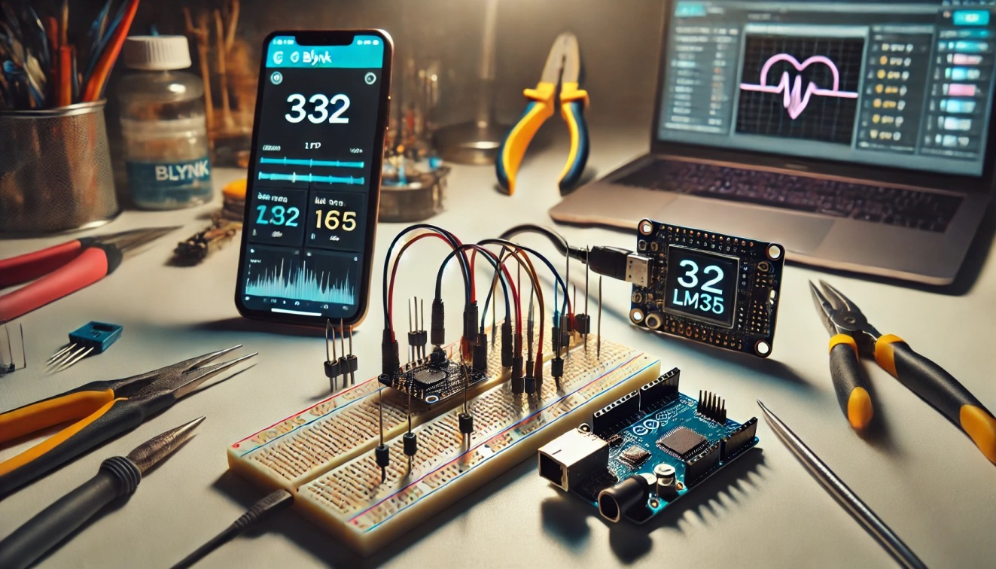

Code Walkthrough:
#define BLYNK_TEMPLATE_ID "TMPL6Q-32OiDx"
#define BLYNK_TEMPLATE_NAME "Health Monitor"
#define BLYNK_AUTH_TOKEN "0rtzMHto8xypq5O4PMypSusER2XxwRXt" // Blynk Auth Token
The code begins by defining the necessary parameters for the Blynk app, including the template ID, template name, and the authentication token used to connect to the Blynk platform.
#include <WiFi.h>
#include <BlynkSimpleEsp32.h>
#include <PulseSensorPlayground.h>
#include <LiquidCrystal.h>
#include <ESP_Mail_Client.h>
The libraries for Wi-Fi, Blynk, PulseSensor, LCD, and ESP Mail Client are included to handle their respective functions.
char ssid[] = "SIBAU-CAFE"; // Wi-Fi SSID
char pass[] = "CafeIB@u"; // Wi-Fi password
Wi-Fi credentials are defined for connecting the ESP32 to the network.
#define SMTP_server "smtp.gmail.com"
#define SMTP_Port 465
#define sender_email "habeebanmemon73@gmail.com"
#define sender_password "zadd griy fica ngrv"
#define Recipient_email "ayeshaansari0921@gmail.com"
The email credentials for Gmail SMTP server are configured. These include the sender's email address, password, and the recipient's email (doctor's email).
PulseSensorPlayground pulseSensor;
LiquidCrystal lcd(rs, en, d4, d5, d6, d7); // LCD setup
The PulseSensor and LCD objects are instantiated for further use.

Heart Rate Monitoring:
if (pulseSensor.sawStartOfBeat()) {
myBPM = pulseSensor.getBeatsPerMinute();
The heart rate is detected using the PulseSensorPlayground library. If a heartbeat is detected, the BPM is calculated.

Temperature Monitoring:
int tempValue = analogRead(TempPin);
temperature = (tempValue * 3.3 / 4095.0) * 100;
The LM35 sensor value is read and converted into Celsius.

Email Alert System:
if (myBPM < normalMin || myBPM > normalMax) {
sendEmail("High Heart Rate Alert", "The patient's heart rate is dangerously high: " + String(myBPM) + " BPM.");
}
If the heart rate is outside the normal range, an email alert is sent to the doctor with the details of the abnormal heart rate.

Blynk Integration:
Blynk.virtualWrite(V3, myBPM);
Blynk.virtualWrite(V4, temperature);
The heart rate and room temperature values are sent to the Blynk app for remote monitoring.

Code:
#define BLYNK_TEMPLATE_ID "TMPL6Q-32OiDx"
#define BLYNK_TEMPLATE_NAME "Health Monitor"
#define BLYNK_AUTH_TOKEN "0rtzMHto8xypq5O4PMypSusER2XxwRXt"

#include <WiFi.h>
#include <BlynkSimpleEsp32.h>
#include <PulseSensorPlayground.h>
#include <LiquidCrystal.h>
#include <ESP_Mail_Client.h>

char ssid[] = "SIBAU-CAFE";
char pass[] = "CafeIB@u";

#define SMTP_server "smtp.gmail.com"
#define SMTP_Port 465
#define sender_email "habeebanmemon73@gmail.com"
#define sender_password "zadd griy fica ngrv"
#define Recipient_email "ayeshaansari0921@gmail.com"
#define Recipient_name "Dr: Ayesha"

const int PulseWire = 34;
const int TempPin = 33;
const int LED = 2;
const int Buzzer = 32;
const int rs = 16, en = 4, d4 = 17, d5 = 5, d6 = 18, d7 = 19;

int Threshold = 550;
PulseSensorPlayground pulseSensor;

LiquidCrystal lcd(rs, en, d4, d5, d6, d7);

int normalMin = 60;
int normalMax = 100;
int myBPM = 0;

float temperature = 0.0;

bool wifiConnected = false;

SMTPSession smtp;

unsigned long lastEmailSentTime = 0;

void sendEmail(String subject, String messageBody) {
unsigned long currentTime = millis();

if (currentTime - lastEmailSentTime < 15000) {
Serial.println("Email will be sent after 15 seconds.");
return;
}

ESP_Mail_Session session;
session.server.host_name = SMTP_server;
session.server.port = SMTP_Port;
session.login.email = sender_email;
session.login.password = sender_password;

SMTP_Message message;
message.sender.name = "Patient Habiba Health Monitor Alert!!";
message.sender.email = sender_email;
message.subject = subject.c_str();
message.addRecipient(Recipient_name, Recipient_email);

String htmlMsg = "<div style=\"color:#000000;\"><h2>Health Monitor Alert</h2><p>" + messageBody + "</p></div>";
message.html.content = htmlMsg.c_str();
message.html.charSet = "us-ascii";

if (!smtp.connect(&session)) {
Serial.println("Error connecting to SMTP server: " + smtp.errorReason());
return;
}

if (!MailClient.sendMail(&smtp, &message)) {
Serial.println("Error sending Email: " + smtp.errorReason());
} else {
Serial.println("Email sent successfully!");
lastEmailSentTime = currentTime;
}
}

void setup() {
Serial.begin(115200);

WiFi.begin(ssid, pass);
Serial.print("Connecting to Wi-Fi...");
for (int i = 0; i < 20; i++) {
if (WiFi.status() == WL_CONNECTED) {
wifiConnected = true;
Serial.println("\nConnected to Wi-Fi.");
break;
}
delay(500);
Serial.print(".");
}
if (wifiConnected) {
Blynk.begin(BLYNK_AUTH_TOKEN, ssid, pass);
Serial.println("Connected to Blynk.");
} else {
Serial.println("\nWi-Fi not connected. Running offline.");
}

pulseSensor.analogInput(PulseWire);
pulseSensor.blinkOnPulse(LED);
pulseSensor.setThreshold(Threshold);

if (pulseSensor.begin()) {
Serial.println("Pulse sensor initialized!");
} else {
Serial.println("Pulse sensor initialization failed!");
}

lcd.begin(16, 2);
lcd.clear();
lcd.setCursor(0, 0);
lcd.print("Patient Health");
lcd.setCursor(0, 1);
lcd.print("Monitor System");
delay(5000);
lcd.clear();

lcd.setCursor(0, 0);
lcd.print("Made By:");
lcd.setCursor(0, 1);
lcd.print("Habiba & Ayesha");
delay(5000);
lcd.clear();

pinMode(Buzzer, OUTPUT);
digitalWrite(Buzzer, LOW);
smtp.debug(1);
}

void loop() {
if (wifiConnected) {
Blynk.run();
}

if (pulseSensor.sawStartOfBeat()) {
myBPM = pulseSensor.getBeatsPerMinute();

if (myBPM > 40 && myBPM < 180) {
Serial.print("BPM: ");
Serial.println(myBPM);

lcd.setCursor(0, 0);
lcd.print("Heart Rt: ");
lcd.print(myBPM);
lcd.print(" BPM ");

lcd.setCursor(0, 1);
if (myBPM < normalMin) {
lcd.print("Low HR Alert! ");
digitalWrite(Buzzer, HIGH);
Serial.println("Low Heart Rate!");
sendEmail("Low Heart Rate Alert", "The patient's heart rate is dangerously low: " + String(myBPM) + " BPM.");
} else if (myBPM > normalMax) {
lcd.print("High HR Alert!");
digitalWrite(Buzzer, HIGH);
Serial.println("High Heart Rate!");
sendEmail("High Heart Rate Alert", "The patient's heart rate is dangerously high: " + String(myBPM) + " BPM.");
} else {
lcd.print("HR Normal ");
digitalWrite(Buzzer, LOW);
Serial.println("Normal Heart Rate.");
}

if (wifiConnected) {
Blynk.virtualWrite(V3, myBPM);
}
}
}

int tempValue = analogRead(TempPin);
temperature = (tempValue * 3.3 / 4095.0) * 100;

char tempStr[6];
dtostrf(temperature, 4, 1, tempStr);

lcd.setCursor(0, 1);
lcd.print("Room Tmp: ");
lcd.print(tempStr);
lcd.print(" C ");

if (wifiConnected) {
Blynk.virtualWrite(V4, temperature);
}

delay(4000);
}

Circuit Diagram:
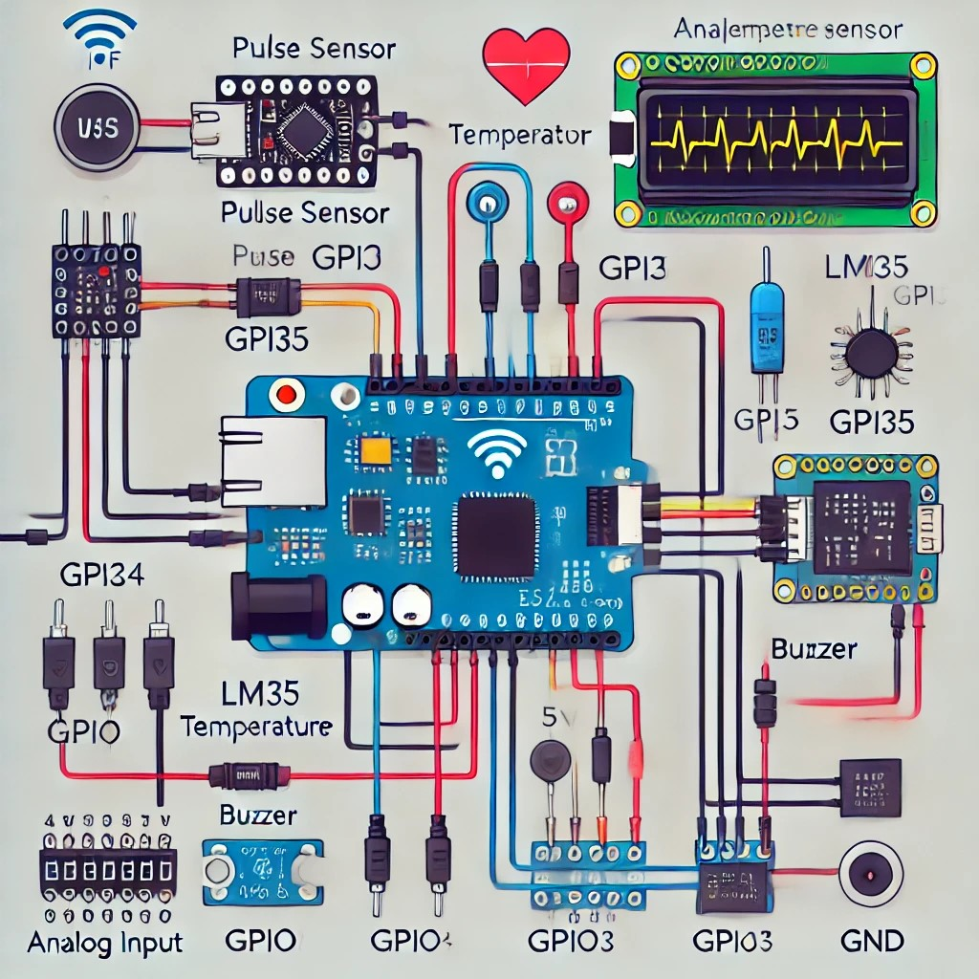
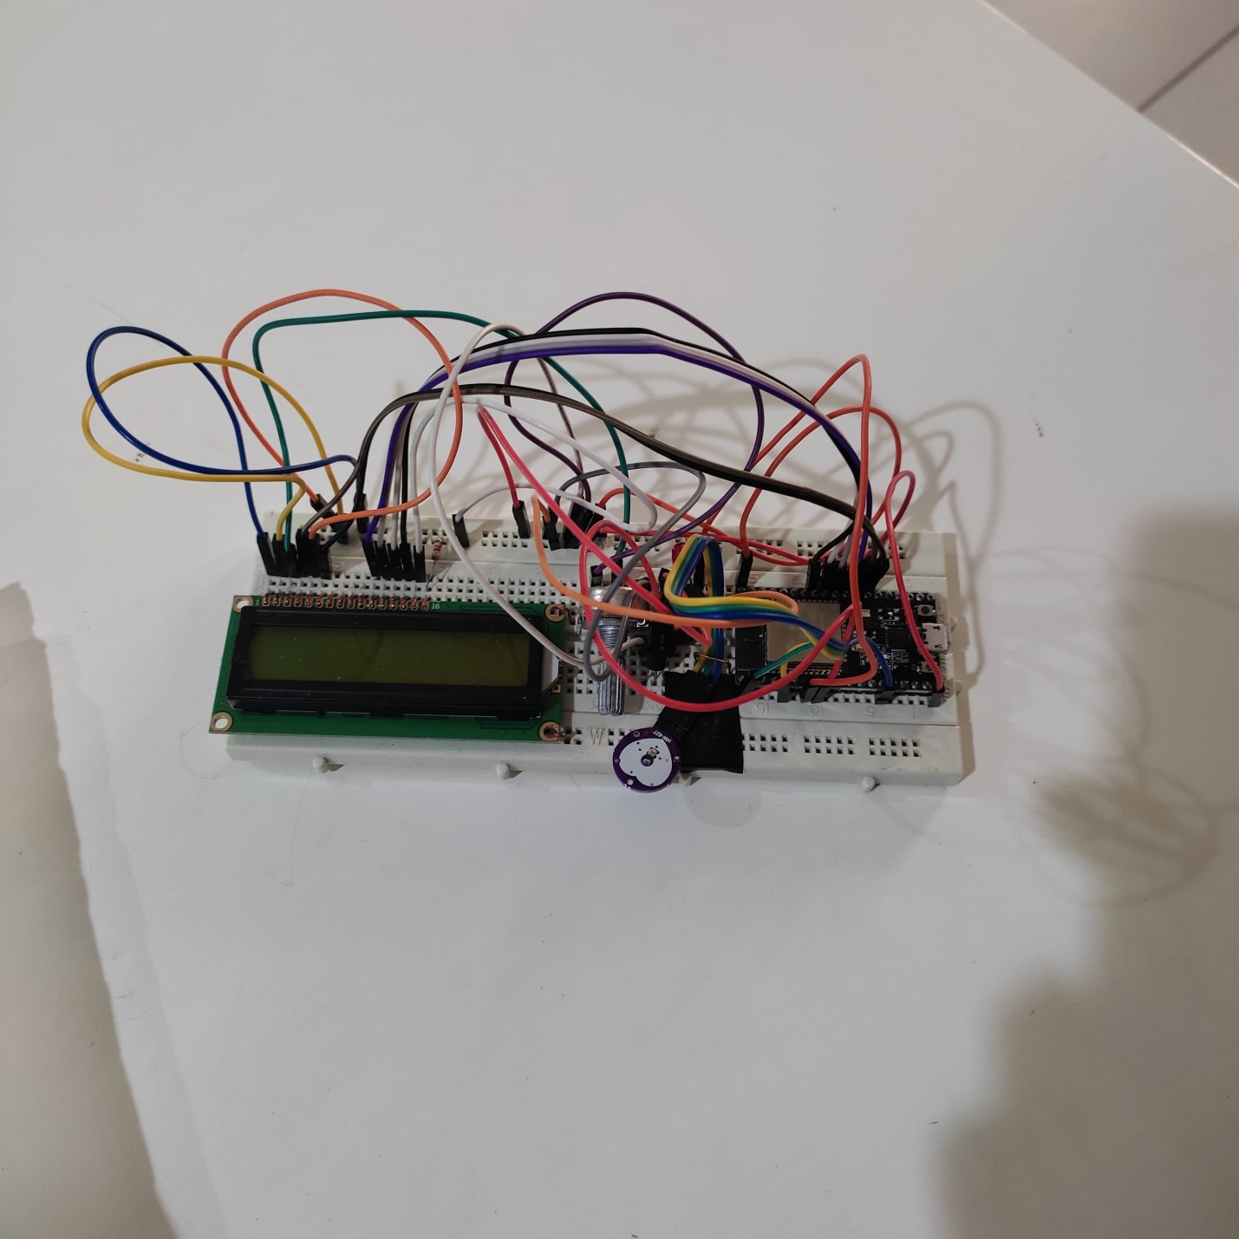
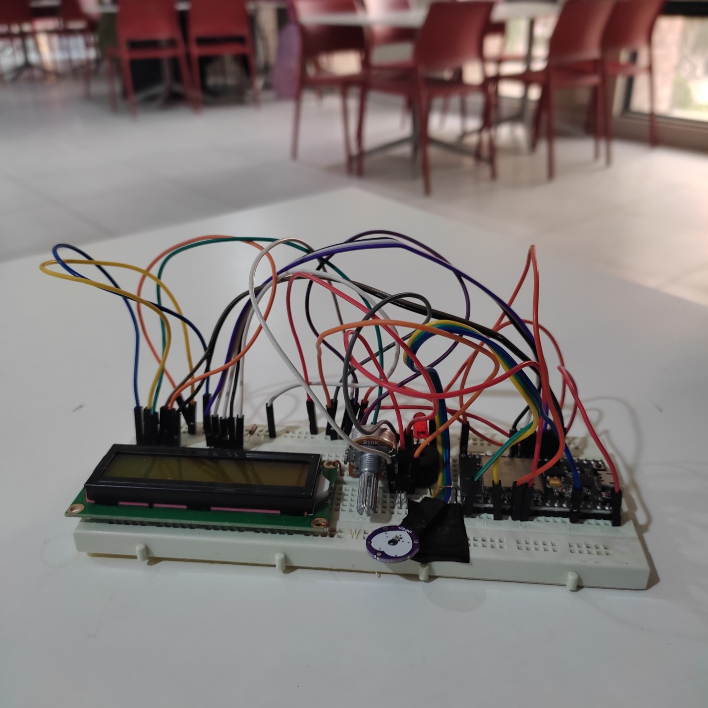
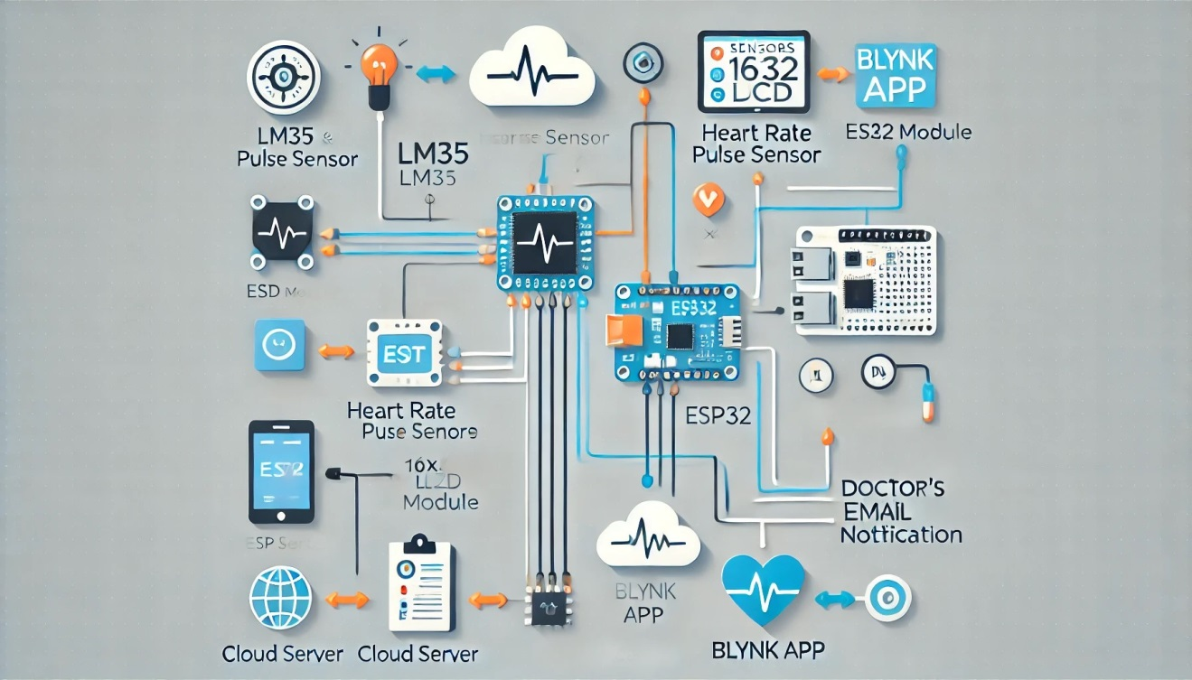

Results:
The system was successfully built and tested, with the following outcomes:
- Heart Rate Monitoring: The PulseSensor accurately detected the heart rate, and the data was displayed on both the LCD and the Blynk app. When the heart rate exceeded or fell below the normal range (60-100 BPM), the system displayed an alert on the LCD and triggered an email to the doctor.
- Room Temperature Monitoring: The LM35 sensor provided accurate readings of room temperature, which were displayed on the LCD and sent to the Blynk app.
- Email Alerts: The email system was successfully implemented. When the heart rate went beyond the normal range, an email was sent to the doctor’s email address with the patient’s health data.
- Remote Monitoring: The Blynk app allowed remote monitoring of the health parameters. The data was updated in real-time, and the app displayed the heart rate and temperature in an easy-to-understand format.
- User Alerts: The buzzer and LCD alerts were triggered effectively when the heart rate went beyond normal limits, providing immediate feedback to the user.

Output:
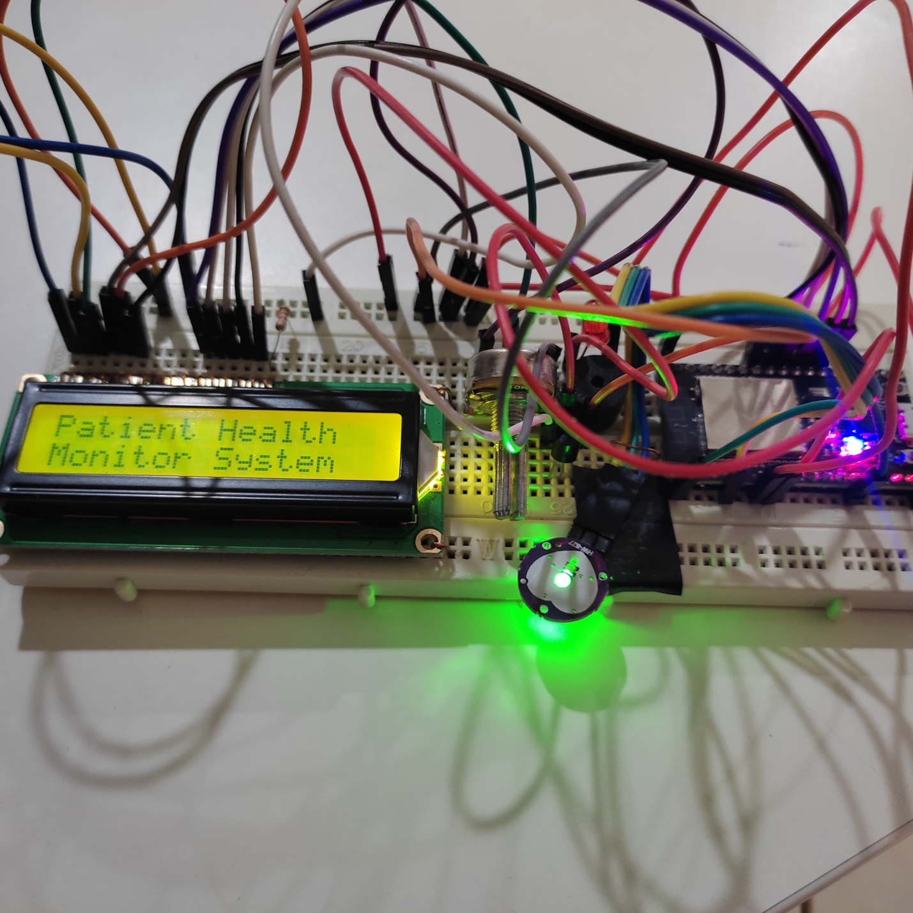
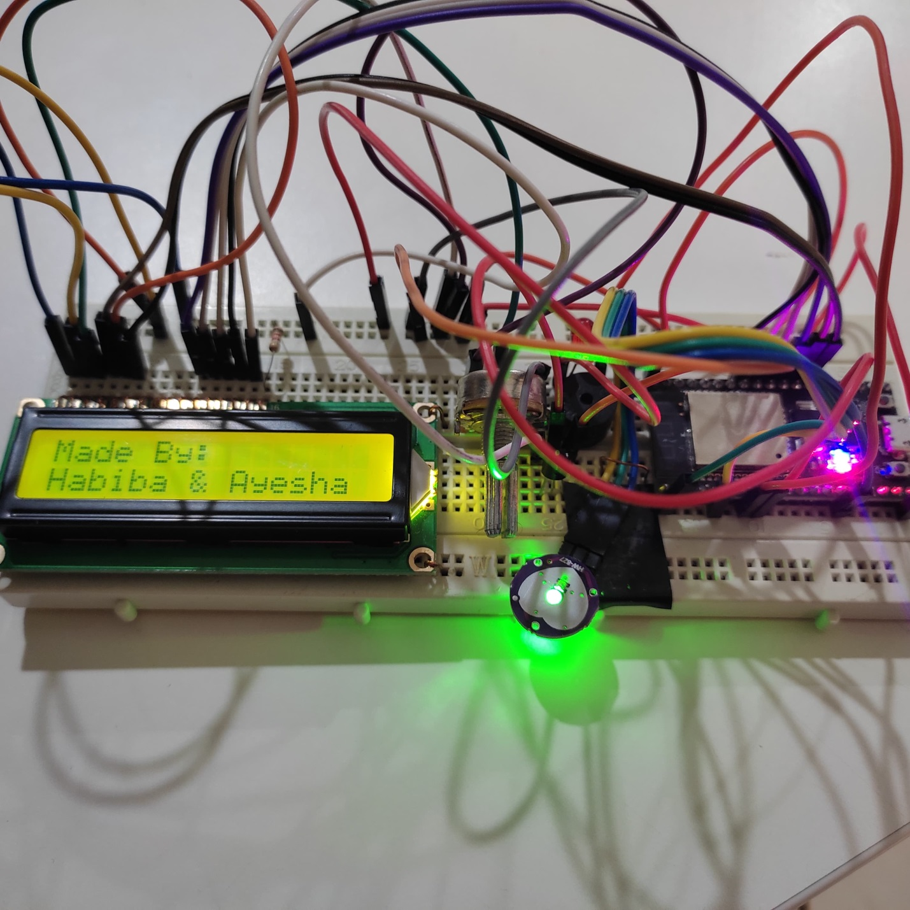
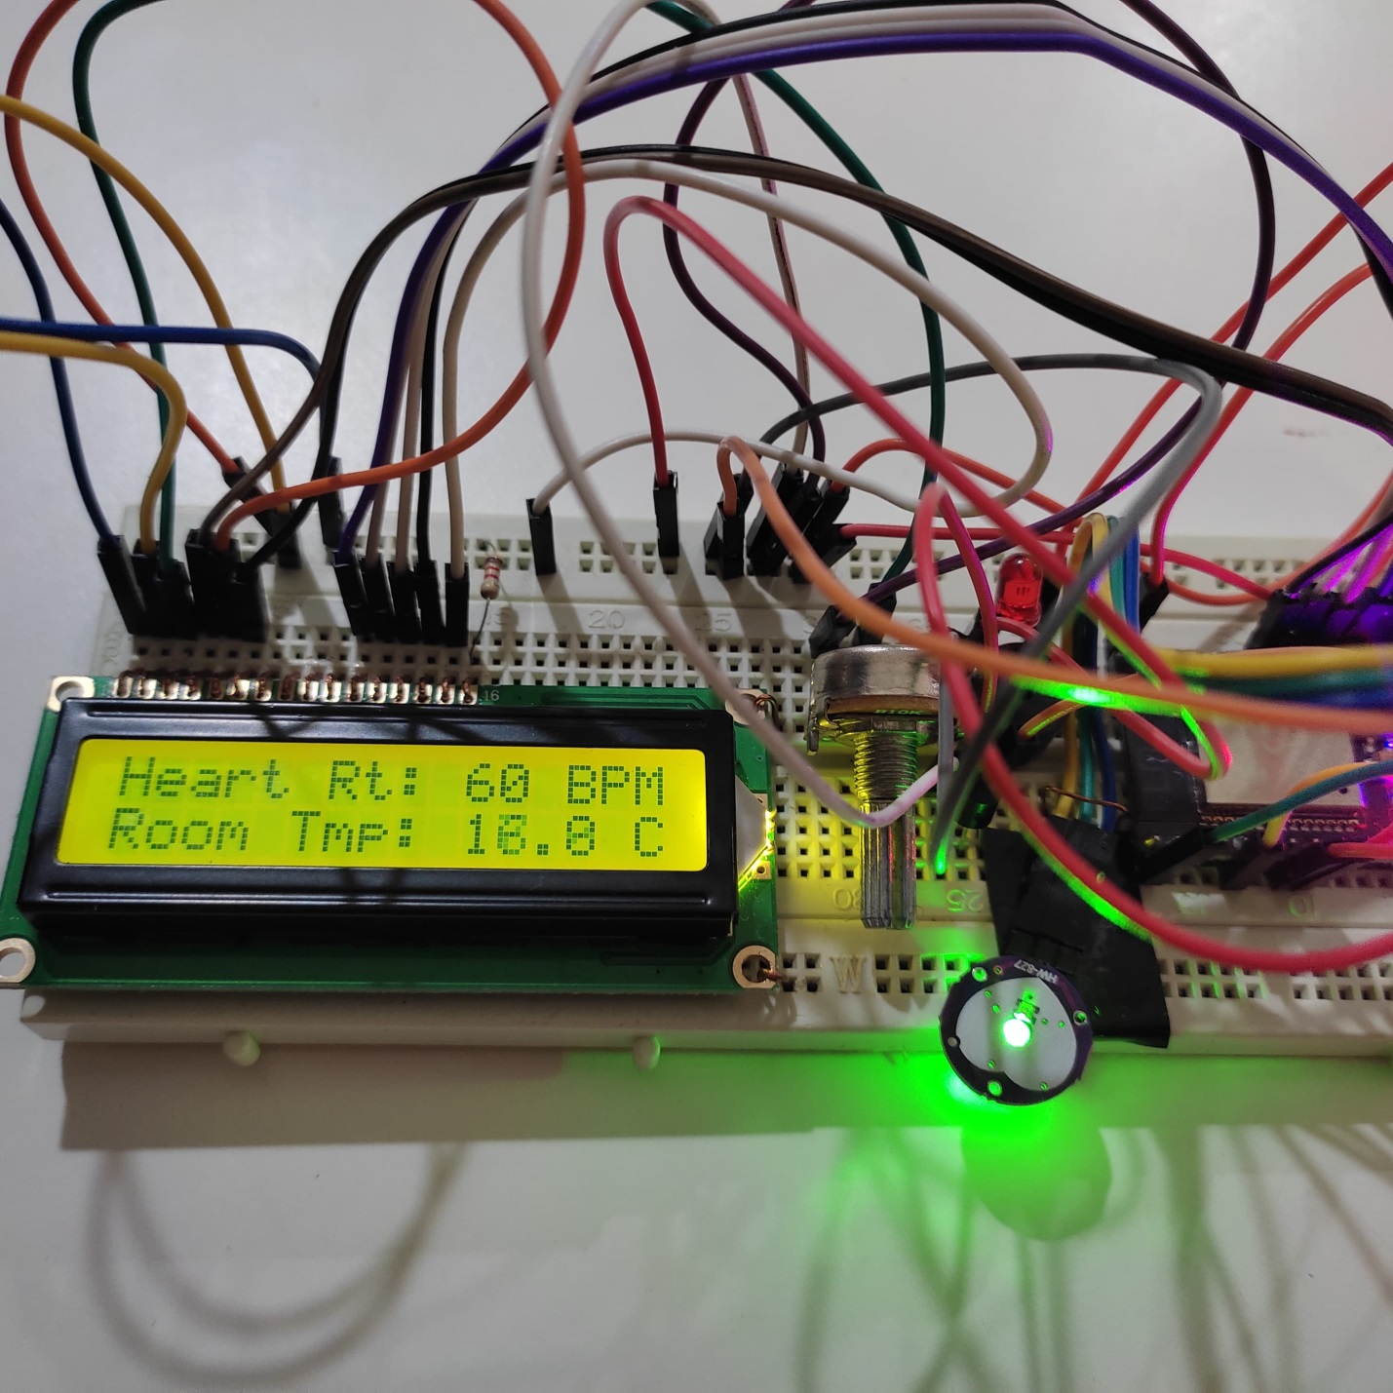

Advantages:
- Real-Time Monitoring: The system provides real-time monitoring of both heart rate and room temperature. The immediate display on the LCD screen and the Blynk app ensures that the user and healthcare provider can continuously monitor these critical health parameters, facilitating early detection of any abnormalities.
- Remote Access: The integration with the Blynk app allows for remote monitoring, which means healthcare professionals or caregivers can access the data from any location with an internet connection. This feature adds convenience and ensures that health parameters are closely monitored, even when the user is not physically present.
- Emergency Alerts: If the heart rate crosses predefined thresholds (too high or too low), the system sends automated email alerts to the doctor or a designated healthcare professional. This feature helps in preventing life-threatening situations by providing timely alerts for medical intervention.
- Cost-Effective: Traditional health monitoring systems used in hospitals can be expensive and complex. This system provides a low-cost alternative that is accessible to individuals at home, especially for those with chronic health conditions or the elderly, who may need regular health monitoring.
- User-Friendly Interface: The system is equipped with a 16x2 LCD that provides clear, easily readable data. Additionally, the buzzer alerts the user when their heart rate is abnormal, providing immediate feedback in case of an emergency.
- Scalable and Expandable: The system is highly scalable, meaning that it can be easily modified or extended to include more sensors (e.g., blood pressure, oxygen saturation, etc.), making it suitable for comprehensive health monitoring.

Challenges and Limitations:
- Sensor Accuracy: While the PulseSensor and LM35 sensors provide useful data, their accuracy might be affected by various environmental factors. For instance, the LM35 may not be suitable for extremely low temperatures or highly fluctuating environmental conditions. The PulseSensor might also be less accurate in certain individuals (e.g., those with irregular heartbeats or poor circulation).
- Limited Monitoring Parameters: Currently, the system only monitors heart rate and room temperature, which limits its ability to provide a full picture of a person's health. For comprehensive health management, additional sensors (e.g., blood pressure, oxygen levels) are needed.
- Email Alert Delay: Although the email alert system is effective, it is limited by internet connectivity and may experience delays in sending emails, especially if the Wi-Fi connection is unstable or slow.
- Dependency on Wi-Fi: The system heavily relies on Wi-Fi for both Blynk app communication and email alerts. If the Wi-Fi connection is lost, the system would be unable to send data to the app or send email alerts, leading to a potential loss of critical information in case of emergencies.
- Power Consumption: The system requires continuous power for real-time monitoring and alerts, making it less suitable for applications that require battery-operated devices. Although the ESP32 is energy-efficient, constant use of Wi-Fi and sensors may still lead to higher power consumption over time.
- Limited Alert Mechanisms: The only form of immediate alert is the buzzer on the device. In certain situations, the user may not hear the buzzer, especially in noisy environments or if the user is asleep. This limitation restricts the system’s effectiveness in emergency scenarios.
- User Experience: While the system works well for basic monitoring, the user interface (especially the LCD display) is quite basic. In cases where more data or interactive features are required, the limited screen size and functionality might not suffice.

Future Enhancements:
- Integration of More Sensors: To make the system more comprehensive, additional sensors could be added to monitor other important health metrics such as blood pressure, oxygen saturation, ECG, or blood glucose levels. By integrating these sensors, the system could provide a more complete health profile and offer more accurate health assessments.
- Cloud Integration: The system could benefit from the integration with cloud platforms (e.g., Google Firebase, ThingSpeak, or AWS IoT), which would allow for secure data storage, analytics, and advanced visualizations. Data could be stored in the cloud for long-term tracking and analysis, providing insights into trends over time.
- Improved User Interface: The user interface could be improved by integrating OLED displays or Touchscreen displays, offering a more interactive and user-friendly experience. A more sophisticated interface could also enable users to interact with the system, customize settings, and view historical data on the LCD itself.
- Voice Alerts and Notification System: Instead of relying on a buzzer alone, the system could be enhanced with a voice alert system. For example, the device could use text-to-speech (TTS) technology to notify the user about their health status, such as “Heart rate is normal” or “Please seek medical attention immediately.”
- Mobile App Development: While the Blynk app serves as a remote monitoring platform, the development of a dedicated mobile health app could allow users to track their health data, set reminders, view detailed statistics, and receive push notifications. The app could also allow users to access their historical data, making it easier for doctors to review trends during consultations.
- Battery-Powered Design: To address the issue of power consumption, the system could be upgraded to be more energy-efficient and powered by rechargeable batteries or solar panels. This would make the system more portable and usable in remote locations or for users who need mobile health monitoring solutions.
- AI and Machine Learning Integration: In the future, Artificial Intelligence (AI) and Machine Learning (ML) algorithms could be incorporated to analyze the health data and predict potential health issues. The system could learn from patterns in the user's heart rate and temperature data to offer predictive insights and notify users or doctors about potential health risks before they become critical.
- Telemedicine Integration: Integrating the health monitoring system with telemedicine platforms could allow doctors to remotely monitor patients in real-time, providing proactive care and guidance. The doctor could communicate directly with the patient, offering timely advice or requesting further action if necessary.
- Multiple User Profiles: The system could be enhanced to handle multiple user profiles. This would allow different individuals to use the same device while tracking their personal health data separately. This feature would be useful in household or family settings.
- Integration with Wearable Devices: The system could be extended by integrating with wearable health devices such as smartwatches or fitness trackers. Data from these devices could be fed into the health monitoring system to provide an even more comprehensive view of a person’s health metrics.

Conclusion:
This project successfully demonstrates the power of IoT and real-time monitoring in healthcare. By integrating the PulseSensor, LM35 sensor, ESP32 microcontroller, and Blynk app, the system enables continuous monitoring of heart rate and temperature, with the added feature of sending email alerts in case of abnormal readings. This provides a reliable, affordable, and easy-to-use solution for monitoring vital health parameters.
The system can be expanded to include additional health sensors such as blood pressure, oxygen levels, or even ECG monitoring, further enhancing its capabilities. The integration of Blynk ensures that data is accessible remotely, improving convenience for both users and healthcare providers. This system offers an excellent solution for patients with chronic conditions, elderly individuals, or anyone in need of continuous health monitoring, providing peace of mind for both the user and their caregivers.
In the future, this system could be scaled up and used as a prototype for a personal health management system, integrating various health metrics to provide comprehensive and actionable insights into the user's health, enabling proactive medical intervention.

